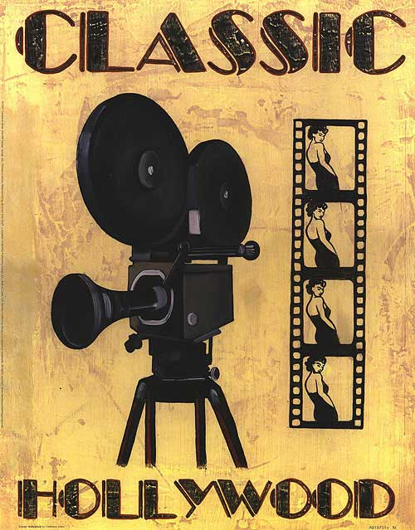

Classical Hollywood cinema, classical Hollywood narrative, the Golden Age of Hollywood, Old Hollywood, and classical continuity are terms used in film criticism which designate both a narrative and visual style of film-making which developed in and characterized American cinema between the 1910s and the 1960s, and eventually became the most powerful and pervasive style of film-making worldwide. For centuries, the only visual standard of narrative storytelling was the theatre. Since the first narrative films in the 1890s, film-makers sought to capture the power of live theatre on the cinema screen. Most of these film-makers started as directors on the late 19th century stage, and likewise most film actors had roots in vaudeville or theatrical melodramas. Visually, early narrative films had adapted little from the stage, and their narratives had adapted very little from vaudeville and melodrama. Before the visual style which would become known as "classical continuity", scenes were filmed in full shot and used carefully choreographed staging to portray plot and character relationships. Cutting was extremely limited, and mostly consisted of close-ups of writing on objects for their legibility. The narrative and visual style of classical Hollywood style would further develop after the transition to sound-film production. The primary changes in American film-making came from the film industry itself, with the height of the studio system. This mode of production, with its reigning star system bankrolled by several key studios, had preceded sound by several years. By mid-1920, most of the prominent American directors and actors, who had worked independently since the early 10s, would have to become a part of the new studio system to continue to work. Many great works of cinema that emerged from this period were of highly regimented film-making. One reason this was possible is that, with so many films being made, not everyone had to be a big hit.

